# Vendor is not defined in company code

This is a same error case can be used as a reference:

Ticket number:INC3385609

Interface error message：

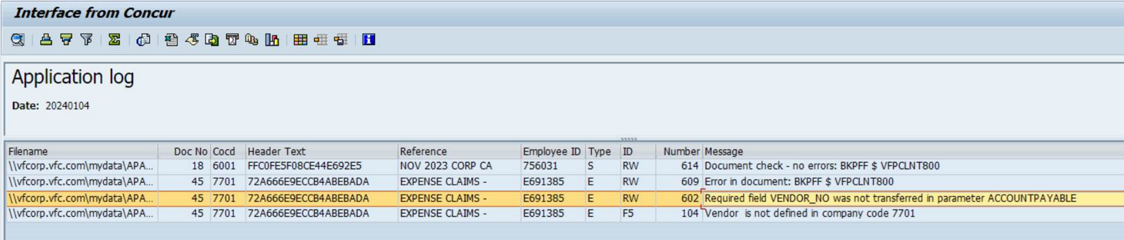

Solution：

After MDMD team created vendor master data, job will auto process again, then the document can be generated as expected.

III

# G/L account XXXX is not defined in company code

Incident No.: INC3385609

Interface error message：

|  |  |  |  |
| --- | --- | --- | --- |
| Cocd | Header Text | Employee ID | Message |
| 6001 | FFC0FE5F08CE44E692E5 | 756031 | G/L account 14010020 is not defined in company code 6001 |

Solution：

Confirm the GL information with user, then modify the file, update the file in SAP folder waiting the auto job process it again, then the document can be generated.

III